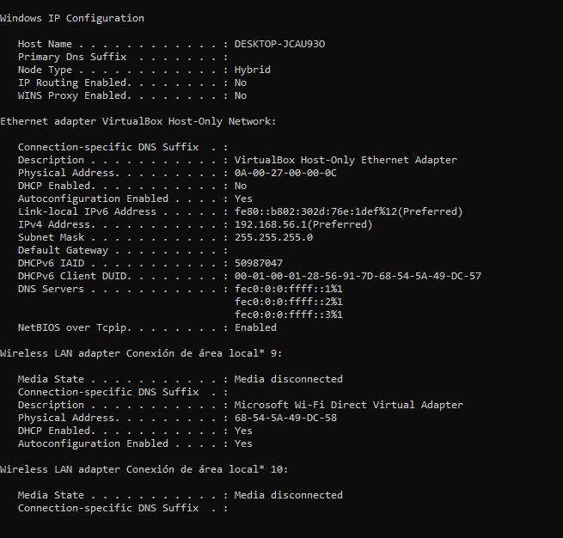

Windows IP Configuration

Host Name . . . . . . . . . . . . : DESKTOP-JCAU93O

Primary Dns Suffix . . . . . . . :

Node Type . . . . . . . . . . . . : Hybrid

IP Routing Enabled. . . . . . . . : No

WINS Proxy Enabled. . . . . . . . : No

Ethernet adapter VirtualBox Host-Only Network:

Connection-specific DNS Suffix . :

Description . . . . . . . . . . . : VirtualBox Host-Only Ethernet Adapter

Physical Address. . . . . . . . . : 0A-00-27-00-00-0C

DHCP Enabled. . . . . . . . . . . : No

Autoconfiguration Enabled . . . . : Yes

Link-local IPv6 Address . . . . . : fe80::b802:302d:76e:1def%12(Preferred)

IPv4 Address. . . . . . . . . . . : 192.168.56.1(Preferred)

Subnet Mask . . . . . . . . . . . : 255.255.255.0

Default Gateway . . . . . . . . . :

DHCPv6 IAID . . . . . . . . . . . : 50987047

DHCPv6 Client DUID. . . . . . . . : 00-01-00-01-28-56-91-7D-68-54-5A-49-DC-57

DNS Servers . . . . . . . . . . . : fec0:0:0:ffff::1%1

fec0:0:0:ffff::2%1

fec0:0:0:ffff::3%1

NetBIOS over Tcpip. . . . . . . . : Enabled

Wireless LAN adapter Conexión de área local\* 9:

Media State . . . . . . . . . . . : Media disconnected

Connection-specific DNS Suffix . :

Description . . . . . . . . . . . : Microsoft Wi-Fi Direct Virtual Adapter

Physical Address. . . . . . . . . : 68-54-5A-49-DC-58

DHCP Enabled. . . . . . . . . . . : Yes

Autoconfiguration Enabled . . . . : Yes

Wireless LAN adapter Conexión de área local\* 10:

Media State . . . . . . . . . . . : Media disconnected

Connection-specific DNS Suffix . :

Description . . . . . . . . . . . : Microsoft Wi-Fi Direct Virtual Adapter #2

Physical Address. . . . . . . . . : 6A-54-5A-49-DC-57

DHCP Enabled. . . . . . . . . . . : No

Autoconfiguration Enabled . . . . : Yes

Wireless LAN adapter Wi-Fi 2:

Connection-specific DNS Suffix . :

Description . . . . . . . . . . . : Intel(R) Wireless-AC 9560

Physical Address. . . . . . . . . : 68-54-5A-49-DC-57

DHCP Enabled. . . . . . . . . . . : Yes

Autoconfiguration Enabled . . . . : Yes

Link-local IPv6 Address . . . . . : fe80::3962:bb19:84fb:32ae%22(Preferred)

IPv4 Address. . . . . . . . . . . : 192.168.0.104(Preferred)

Subnet Mask . . . . . . . . . . . : 255.255.255.0

Lease Obtained. . . . . . . . . . : martes, 29 de marzo de 2022 20:36:41

Lease Expires . . . . . . . . . . : martes, 29 de marzo de 2022 23:36:41

Default Gateway . . . . . . . . . : 192.168.0.1

DHCP Server . . . . . . . . . . . : 192.168.0.1

DHCPv6 IAID . . . . . . . . . . . : 208163930

DHCPv6 Client DUID. . . . . . . . : 00-01-00-01-28-56-91-7D-68-54-5A-49-DC-57

DNS Servers . . . . . . . . . . . : 192.168.0.1

NetBIOS over Tcpip. . . . . . . . : Enabled

Ethernet adapter Conexión de red Bluetooth:

Media State . . . . . . . . . . . : Media disconnected

Connection-specific DNS Suffix . :

Description . . . . . . . . . . . : Bluetooth Device (Personal Area Network)

Physical Address. . . . . . . . . : 68-54-5A-49-DC-5B

DHCP Enabled. . . . . . . . . . . : Yes

Autoconfiguration Enabled . . . . : Yes